Answers
Task 1
Look at the following devices, some of which are robots. For each one, tick whether it has the following features that are needed for robots:
- A mechanical structure or framework
- Electrical components (such as sensors, microprocessors and actuators)
- Programmable
Also, make one tick to identify whether each row is a robot.
Device name | Image of device | Contains a mechanical structure / framework | Contains electrical components (sensors, microprocessors, actuators) | Is it programmable? | Is it a robot?
Ford Escort (1996) | 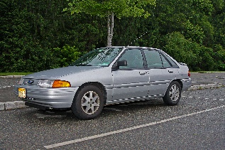
Self-driving delivery vehicles | 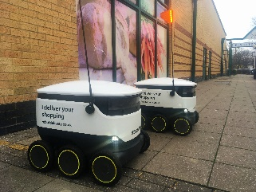
Lawn mower | 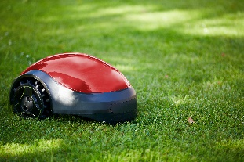
Robotic arm | 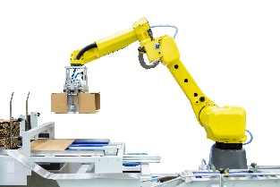
Lego® toy house | 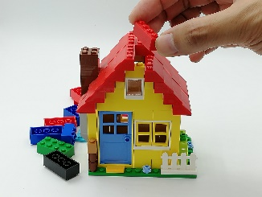
Mindstorms programmable Lego | 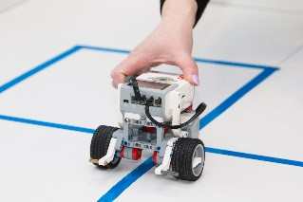
Bike delivery | 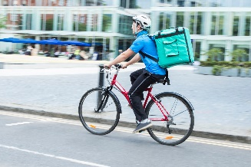

Task 2
Look at the following robot arm.
3
2
4
1
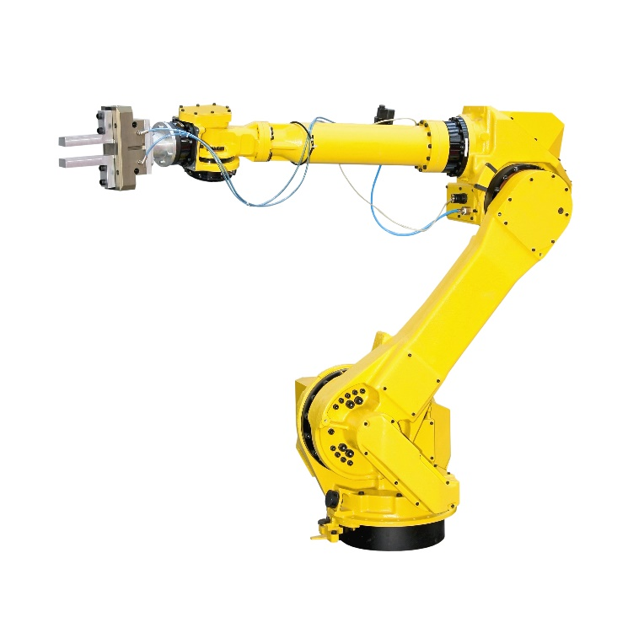
8
7
6
5
Identify seven actuators on the robot arm by circling or drawing arrows to them. Label each arrow between 1 and 7.
Discuss with a partner how the actuators can be moved so that the arm is able to grab an object on the table.
Answers will vary. Some suggested points include:
- Actuators 1 and 5 will move apart so they can be lowered over the object.
- Actuators 1 and 5 will move together to pincer the object. Sensors will detect the amount of pressure that has been applied to avoid damaging the object.
- Actuator 6 will rotate anti-clockwise by around 90º.
- Actuator 4 will rotate so that the top part of the arm is pointing vertically down.
- Actuators 7 and 8 will rotate so that the end of the arm is directly above the object.
- Actuator 2 will rotate so that the grabber is correctly orientated to grab the object.
- Many actuators will move at the same time to make the motion fluid / more efficient

Task 3
Domestic robots include vacuum cleaners, lawn mowers and even robot kitchens.
(a) Research one of these robot types and make notes about how they work below.
You may wish to show students the following videos for additional ideas.
https://www.youtube.com/watch?v=rNcPVvIs_tk
Robot kitchen – behold the future [2m58s]
https://www.youtube.com/watch?v=csGdz5_gZiY
Should you buy a robot vacuum cleaner? [4m36s]
https://www.youtube.com/watch?v=3IQhM0dkiiE
Are robot lawn mowers any good? [7m36s]
The notes that students make will depend on the type of robot they have chosen.
Some summary points:
Robot kitchen – a human chef cooks the meal. The 3D actions that they take are recorded so that the robot can replicate them. Therefore, the robot is very similar to the human (with two arms and hands).
Robot vacuum cleaner – the robot moves forward/turns whilst recording the path where it has been. A camera/touch sensor/ultrasonic sensor detects objects and the edges of the room. An app can control when the cleaner starts/stops or a schedule. The user still needs to empty the dust container.
Robot lawn mower – a wire is placed in the lawn so that the mower knows where the boundaris are. It cuts the grass but leaves the cuttings on the lawn (mulching). As the grass is cut often, this isn’t really noticed as it would be if the lawn were cut once a week. The mower keeps a record of which parts of the lawn it has visited. It has an ultrasonic sensor or push button to detect objects in front.
Ask students to note the importance of sensors, actuators and microprocessor in all the robots they research.
(b) Feedback what you have learnt to the rest of the class.

Task 4
Robot buses have been in use in Finland since 2016. They work alongside ordinary buses, taking up to 12 passengers short distances without a driver.
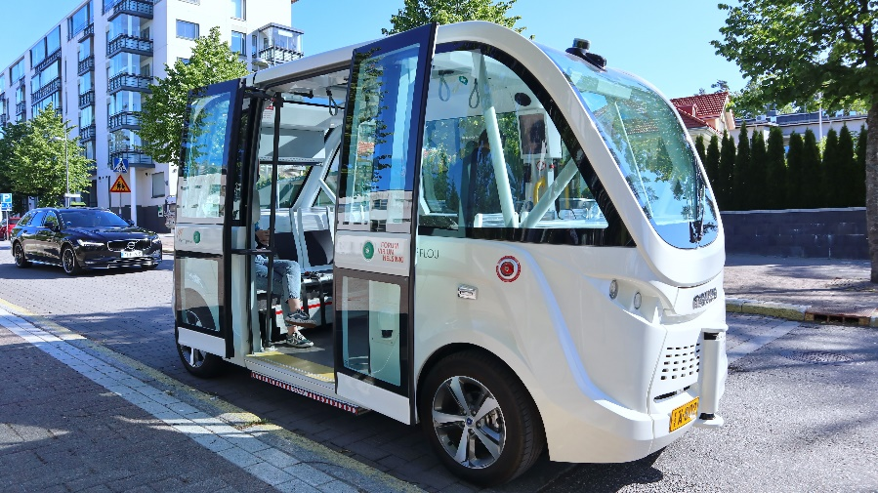
Discuss with a partner or in a small group the advantages and disadvantages of this type of robot.
Record your thoughts in the table below.
Advantages | Disadvantages
No driver required, so reduced costs | Someone may lose their job or there may be fewer jobs available
The robot can work 24 hours a day | There is a high initial cost in the research/development/purchase of the vehicles
The robot can work without breaks | If there is an error in the safety systems/programming, the machine could harm people
The robot may be programmed to drive in the most efficient manner, reducing the environmental impact
Some example advantages and disadvantages are given above.
More information and a video of the buses:
https://www.newsweek.com/self-driving-robot-bus-finland-491847

